 ***SOFTWARE REQUIREMENTS SPECIFICATIONS DOCUMENT***

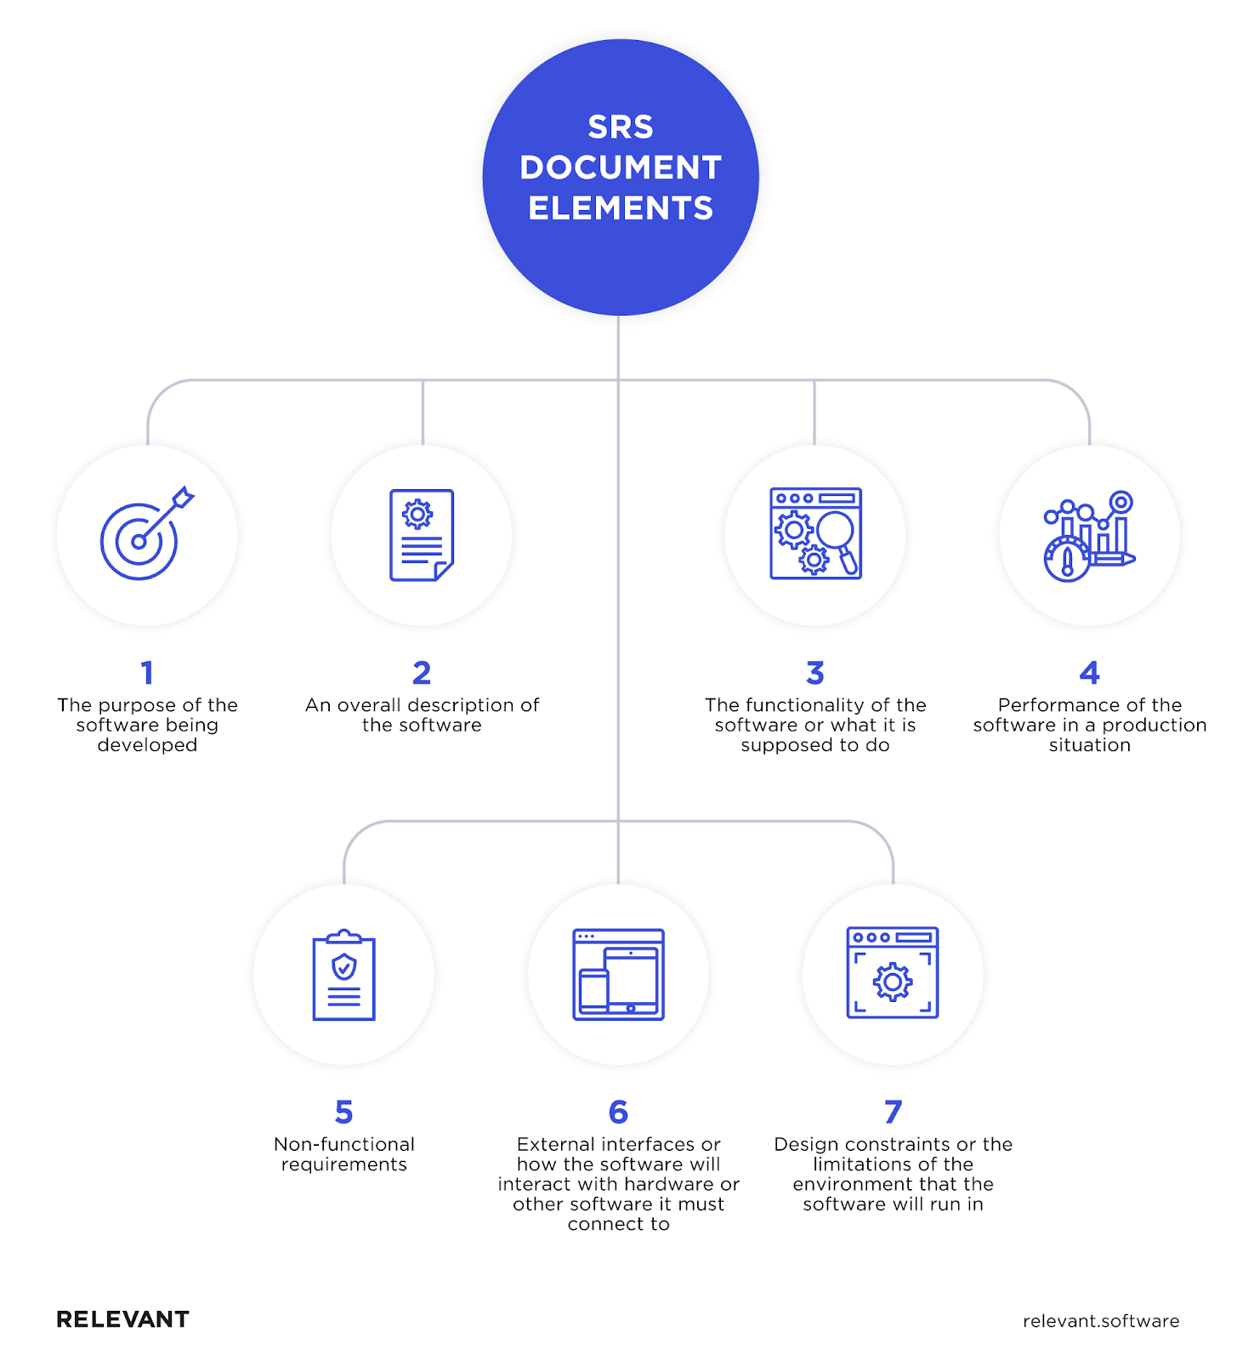

***Introduction:***

Meet JobVengers – your friendly job-hunting sidekick. JobVengers makes finding a job easy and fun. It's like having your own superhero team for your career. We find jobs that match what you're good at and make the whole job search thing simple. Your dream job is out there, and JobVengers is here to help you find it!

***Purpose:***

JobVengers is here to help you find a job that fits your skills and dreams. We make job searching easy and connect you with opportunities that matter. Our goal is to make your career journey simple and enjoyable. Join us to discover a world of job possibilities and success!

***Intended Audience:***

JobVengers is designed for individuals of all backgrounds and experiences who are on the lookout for their next career move. Whether you're a recent graduate, seasoned professional, career changer, or someone exploring new opportunities, JobVengers is your go-to platform.

***App features:***

* Sign up

1. As a job seeker
2. As an employer

* Login in
* Job post
* Job search
* Apply for multiple jobs
* Filter for searching job
* Communication through messages
* Exchange document in form

***User Registration and Login:***

Users can easily sign up as either job seekers or employers.

Secure login feature to access personalized profiles.

Job Seeker Features:

***Job Search:***

Effortlessly search for job opportunities based on keywords, location, or job categories.

Explore a vast array of job listings from various industries.

***Filter Options:***

Implement filters for specific job categories, such as Python Developer or React Developer, to tailor job searches to individual preferences.

Employee Features:

***Job Posting:***

Employers can create and post job openings, providing detailed descriptions of the positions available.

Include specific job requirements, responsibilities, and company information.

***User Profiles:***

Detailed profiles for both job seekers and employers, showcasing skills, experience, and relevant details.

Job seekers can upload resumes in pdf form.

***Communication Platform:***

WhatsApp for seamless communication system between job seekers and employers.

Intuitive and user-friendly design for easy navigation, ensuring a positive user experience.

***Analytics Dashboard:***

Provide both job seekers and employers with analytics on application statuses, job views, and other relevant metrics.

***Multiple Job Applications:***

Allow job seekers to apply for multiple jobs simultaneously.

Streamline the application process to save time for users targeting various opportunities.

***Applications Tracking:***

Implement a dashboard or section where job seekers can track the status of their applications.

Provide details such as application date, status (pending, reviewed, accepted, rejected), and any additional notes.

***Technologies:***

* **Frontend:**

1. **IDE - Android Studio:**
   * Android Studio is the official integrated development environment (IDE) for Android app development.
   * It provides a comprehensive set of tools for designing, coding, testing, and debugging Android applications.
2. **Programming Language - Kotlin:**
   * Kotlin is chosen as the primary programming language for frontend logic development.
   * Known for its concise syntax, safety features, and interoperability with Java, making it a popular choice for Android development.
3. **UI Markup - XML:**
   * XML (eXtensible Markup Language) is used for designing the user interface (UI) of Android applications.
   * Android Studio's layout editor facilitates the creation and modification of UI elements through XML markup.
4. **API Communication - Retrofit:**
   * **Retrofit** is a powerful and widely-used library in Android development for making API calls. It simplifies the interaction with web APIs by providing a clean and efficient way to handle network requests and responses.
   * **Gson**, on the other hand, is a library for JSON serialization and deserialization in Java. It seamlessly integrates with Retrofit, allowing for the automatic conversion of JSON data between the app and the server.
   * **Together, Retrofit with Gson** streamlines the process of connecting Android applications to web APIs. Retrofit handles the networking aspects, making API calls straightforward, while Gson facilitates the conversion of JSON data to Java objects and vice versa. This combination enhances code readability, reduces boilerplate code, and promotes efficient data exchange between the app and the server.
   * Top of Form

* **Backend:**

**XAMPP, PHP, MySQL, Sublime Text, phpMyAdmin, Postman**

1. **Text Editor - Sublime:**
   * Using Sublime Text for writing, editing, and managing our PHP code for API development. It provides a clean and efficient environment for coding.
2. **Local Development Environment - XAMPP:**
   * XAMPP will serve as our local development environment, providing Apache as the web server, MySQL as the database server, and PHP for server-side scripting.
   * It offers a convenient way to develop and test your backend code before deploying it to a live server.
3. **Database - phpMyAdmin with MySQL:**
   * Utilize phpMyAdmin, part of XAMPP, to handle database administration tasks for MySQL.
   * Create, manage, and interact with our MySQL database using phpMyAdmin.
4. **API Development - PHP for APIs:**
   * Using PHP as the server-side scripting language to develop your APIs. Integrate API endpoints, handle HTTP requests, and interact with the MySQL database to send and retrieve data.
5. **API Testing - Postman:**
   * Postman will be our go-to tool for testing our REST APIs. Send requests, receive responses, and ensure our APIs function correctly before integrating them into Android frontend.

* **UI/UX Design - Figma:**

Figma is a cloud-based design tool used for creating user interfaces (UI) and user experience (UX) designs. It allows multiple team members to collaborate in real-time on the design process and is popular for its ease of use and collaborative features.

***Functional requirements:***

***User Registration and Login:***

**User Types:**

1. **Job Seekers and Employers Registration:**
   * Allow users to register as either job seekers or employers.
   * Collect necessary information such as name, email, password, and additional details specific to each type.
2. **Secure Login Functionality:**
   * Implement secure authentication protocols for user login.
   * Verify user credentials before granting access to personalized profiles.

*Job Seeker Features:*

1. ***Job Search:***
   * Implement a search bar allowing users to search for job opportunities using keywords, location, or job categories.
2. *Filter Options:*
   * Enable users to filter job searches based on specific categories, such as job titles or skills (e.g., React Developer, Python Developer).

***Employer Features:***

* ***Job Posting:***
* **User-Friendly Interface:**
  + Design an intuitive interface for employers to post job openings.
  + Include fields for detailed job descriptions, requirements, responsibilities, and company information.
* ***Resume Upload:***

1. **Resume Submission:**
   * Allow job seekers to upload their resumes in PDF format through the app.
   * Implement a secure storage system for resumes.

* ***User Profiles :***

1. **Personalized Profiles:**
   * Create individual profiles for job seekers and employers.
   * Include sections for personal information, work experience, education, and skills.

* ***Communication Channel - WhatsApp:***

1. Implement WhatsApp for seamless communication between job seekers and employers.
   * Leverage the WhatsApp Business API or WhatsApp for Business features to enable messaging within the app.
2. **Integration Steps:**
   * Enable users (job seekers and employers) to connect their WhatsApp accounts within the app.
   * Implement features for sending and receiving messages, notifications, and handling user interactions

***Non-Functional requirements:***

***User Interface:***

**Intuitive Design:**

Design a user-friendly interface ensuring easy navigation and a positive user experience.

***Analytics Dashboard:***

Provide analytics for both job seekers and employers, including application statuses, job views, and other relevant metrics.

***Performance:***

Ensure that the app responds quickly to user actions, with minimal latency in loading job listings and profiles.

***Scalability:***

Design the app to scale efficiently to accommodate a growing user base and increased job postings.

Implement a scalable database architecture to handle a growing number of user profiles, job listings, and interactions.

***Reliability:***

Aim for high system availability, minimizing downtime to ensure users can access the app reliably.

***Security:***

Implement robust data encryption protocols to secure user data and protect sensitive information.

Ensure secure user authentication and authorization processes to prevent unauthorized access.

***Accessibility:***

Design the app interface to be accessible to users with disabilities, following best practices for inclusive design.

***Maintainability:***

Develop clean, modular, and well-documented code to facilitate ease of maintenance and future updates.

***Privacy:***

Adhere to data privacy regulations and standards to protect user privacy and build trust.